|  |  |  |  |  |
| --- | --- | --- | --- | --- |
| **National University of Computer and Emerging Sciences, Lahore Campus** | | | | |
| C:\Users\saif\AppData\Local\Microsoft\Windows\Temporary Internet Files\Content.Word\final design.jpg | **Course:** | **Digital Logic Design** | **Course Code:** | **EE227** |
| **Program:** | **BS(Computer Science)** | **Semester:** | **Spring 2021** |
| **Due Date:** | **2nd April , 2021** | **Weight** |  |
| **Section:** | **A & G** | **Roll No.** |  |
| **Assignment #** | **1** |  |  |
|  |  |  | **Section:** |  |

**Question 1: Arithmetic operation with signed numbers**

1. 33+15 =(00100001)+(00001111)=
2. 56+(-27)=( 00111000)+( 11100101)=

**Question 2: Binary multiplication:**

1. (1010.11)×(110)=
2. (1010.11) ×(1011)=
3. (1011.01) ×(110.1)=

**Question 3: Hexadecimal multiplication:**

1. FA×C3=
2. EF12×3F56=

**Question 4:** Simplify the following Boolean expression:

[*AB'*(*C* + *BD*) + *A' B'*]*C*

*A'BC* + *AB'C'* + *A' B' C'* + *AB'C* + *ABC*

*(AB* + *AC)'* + *A 'B' C*

**Question 5:**

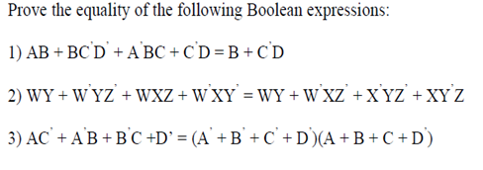

**Question 6:**

